Task Manager App with Angular
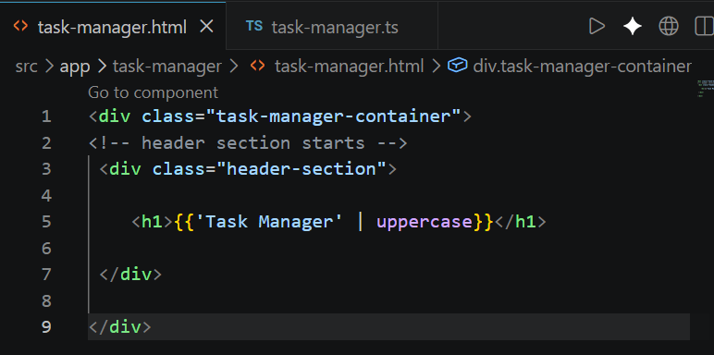

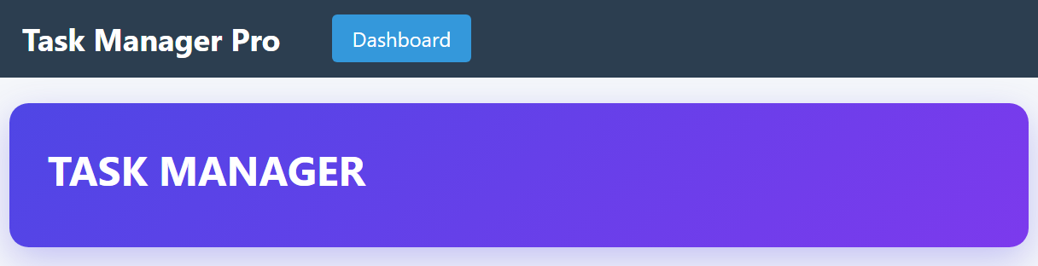
- យើងដាក់ ‘’ នៅក្នុង {{}} interpolation ដើម្បីធ្វើការ ប្រើប្រាស់ syntax from Angular like pipe

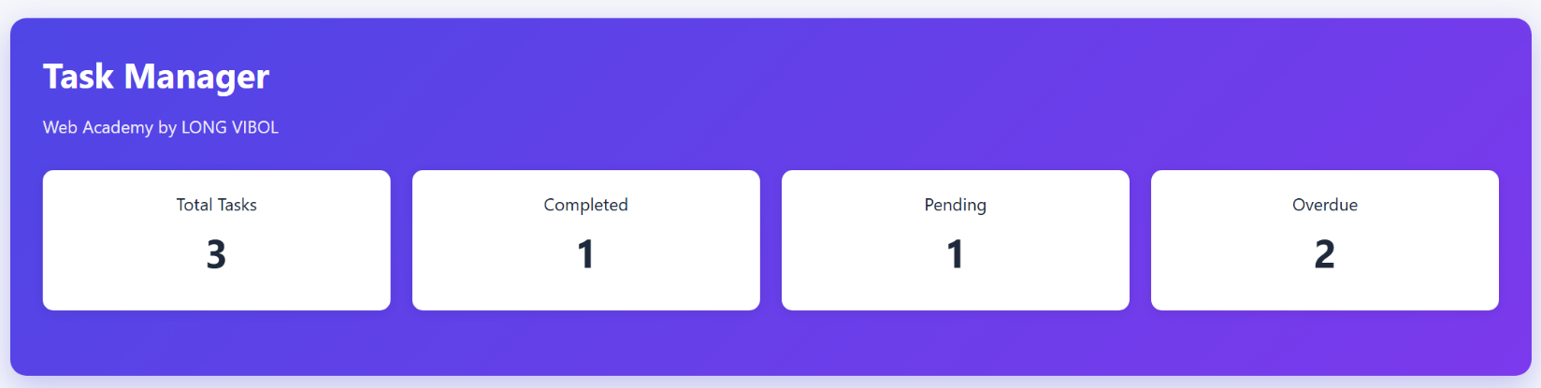

- Create card for Total Tasks, Completed, Pending and Overdue
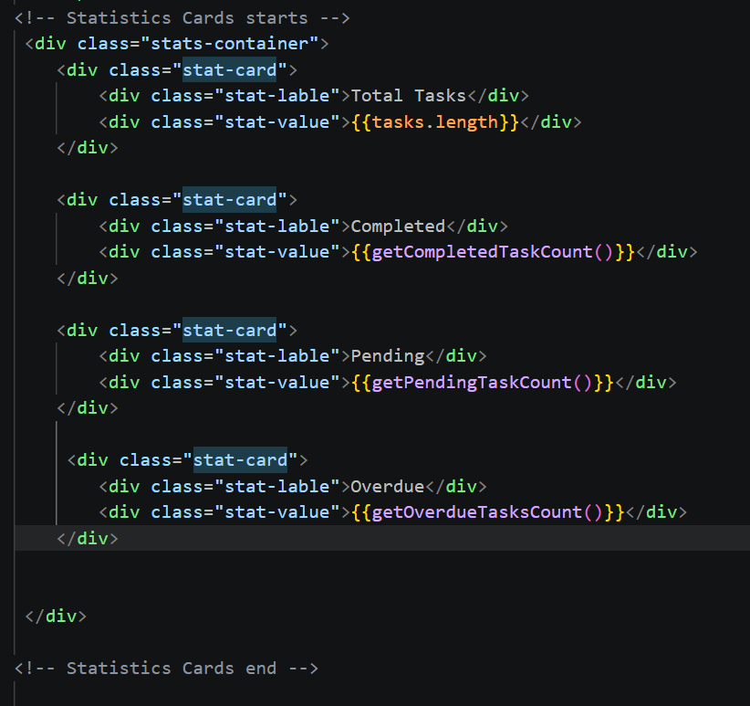

- Create drop down selection

- Create alert notification
Crate condition in the TS and use switch to meet condition in the TS

TS:
getProductivityLevel(){
const rate = this.getCompletionRate();
if (rate >=80) return 'excellent';
if (rate >=60) return 'good';
if (rate >=40) return 'needs-improvement';
return 'poor';
}

HTML
<!-- Productivity alert start -->
<div class="task-manager-container">
@switch(getProductivityLevel()){
@case ('excellent'){
<div class="alert alert-success">
[SUCCESS] Outstanding Productivity!
Keep up the great work!
</div>
}
@case ('good'){
<div class="alert alert-info">
[GOOD] Good Job!
You're maintaining steady progress.
</div>
}
@case ('needs-improvement'){
<div class="alert alert-warning">
[WARNING] Your Productivity could use a boost.
Focus on completing tasks!
</div>
}
@case ('poor'){
<div class="alert alert-danger">
[ALERT] Time to get back on track!
Start with small, easy tasks.
</div>
}
@default {
<div class="alert alert-info">
Keep tracking your tasks!
</div>
}
}

</div>

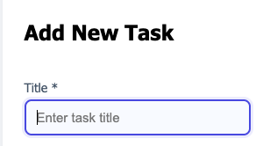
- Create input text

HTML:
<!-- Add Task section starts -->
<div class="add-task-section">
<div class="add-task-header">
<h2>Add New Task</h2>
</div>

<div class="form-grid">
<div class="form-group">
<label>Title *</label>
<input type="text" [(ngModel)]="newTask.title" placeholder="Enter task title"
name="task-title" required (focus)="onFieldFocus('title')" (blur)="onFieldBlur('title')" />
</div>

TS:
//Form data
newTask: {
title: string,
description: string,
category: string,
priority: string,
dueDate: string | Date,
status: string
} = {
title: '',
description: '',
category: '',
priority: 'medium',
dueDate: '',
status: 'pending'
};

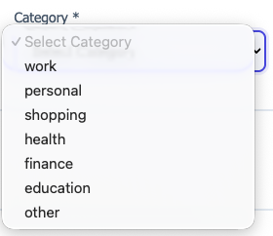
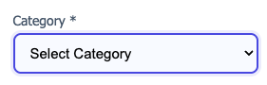
- Category

HTML:
<div class="form-group">
<label>Category *</label>
<select [(ngModel)]="newTask.category" required>
<option value="" disabled>Select Category</option>
@for (category of categories; track category)
{
<option [value]="category">{{category}}</option>
}
</select>
</div>
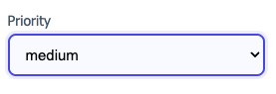
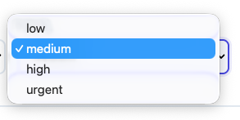
- Priority

<div class="form-group">
<label>Priority</label>
<select [(ngModel)]="newTask.priority">
@for (priority of priorities; track priority)
{
<option [value]="priority">{{priority}}</option>
}
</select>
</div>

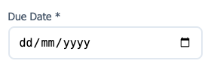
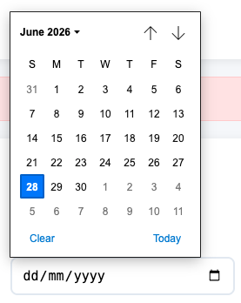
- Due Date

<div class="form-group">
<label>Due Date *</label>
<input type="date" [(ngModel)]="newTask.dueDate" required />
</div>

- Status
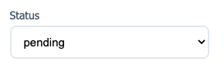
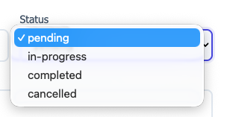

<div class="form-group">
<label>Status</label>
<select [(ngModel)]="newTask.status">
@for (status of statuses; track status)
{
<option [value]="status">{{status}}</option>
}
</select>
</div>

- Description
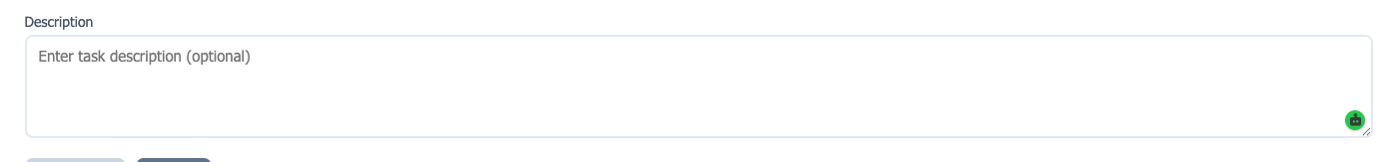

<div class="form-group" style="grid-column: 1 / -1;">
<label>Description</label>
<textarea [(ngModel)]="newTask.description" placeholder="Enter task description (optional)"></textarea>
</div>
</div>

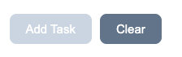
- Button disable and clear

- <div class="form-actions">
- <button class="btn btn-primary" (click)="addTask()" [disabled]="!newTask.title || !newTask.category || !newTask.dueDate"
- [title]="(!newTask.title || !newTask.category || !newTask.dueDate)? 'Please fill in required fields' : 'Add new task'">Add Task</button>

- <button class="btn btn-secondary" (click)="clearForm()">Clear</button>
- </div>

- Alert notification

HTML:
<!-- Productivity alert starts -->
@switch (getProductivityLevel())
{
@case ('excellent')
{
<div class="alert alert-success">
[SUCCESS] Outstanding productivity!
Keep up the great work!
</div>
}
@case ('good')
{
<div class="alert alert-info">
[GOOD] Good job!
You're maintaining steady progress.
</div>
}
@case ('needs-improvement')
{
<div class="alert alert-warning">
[WARNING] Your productivity could use a boost.
Focus on completing tasks!
</div>
}
@case ('poor')
{
<div class="alert alert-danger">
[ALERT] Time to get back on track!
Start with small, easy tasks.
</div>
}
@default
{
<div class="alert alert-info">
Keep tracking your tasks!
</div>
}
}
<!-- Productivity alert ends -->

List Item
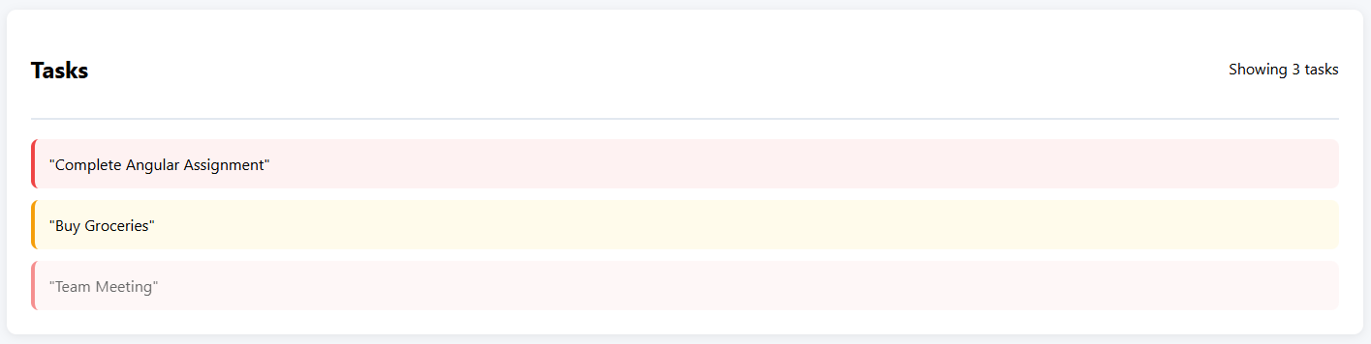

<!-- Tasks List starts -->
<div class="tasks-section">
<div class="section-header">
<h2>Tasks</h2>
<span>Showing {{getFilteredTasks().length}} tasks</span>
</div>
@if (getFilteredTasks().length > 0){
<div class="tasks-list">
@for(task of getFilteredTasks(); track task.id)
{
<div class="task-item"
[class]="'priority-' + task.priority"
[class.task-completed]="task.status === 'completed'"
>
{{task.title | json}}
</div>
}
</div>
}
</div>
<!-- Tasks List ends -->
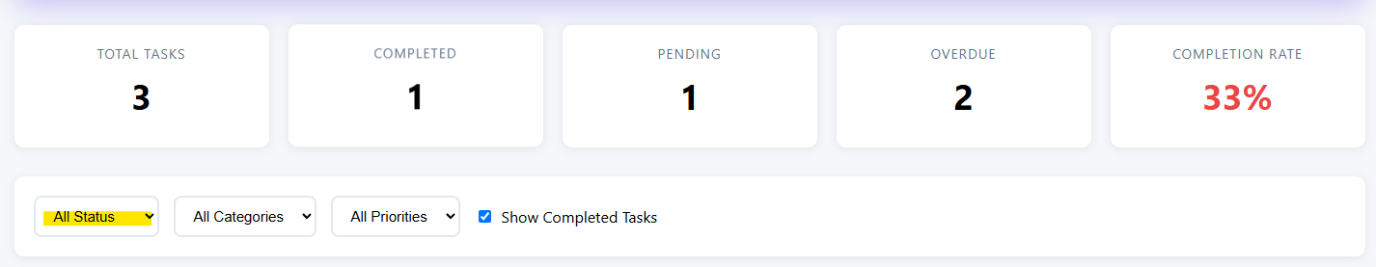

- This is what we filter based on the drop-down list. If it is pending it will show the list of pending.
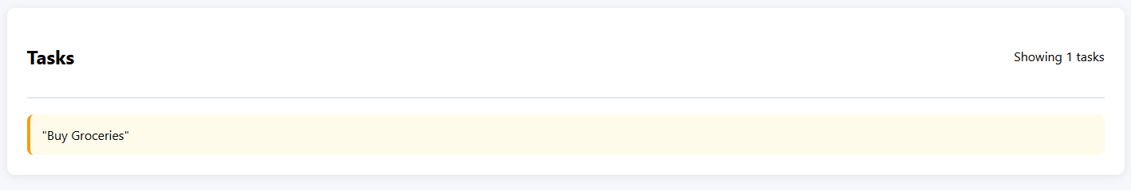
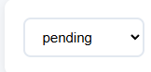

HTML:
<!-- Tasks List starts -->
<div class="tasks-section">
<div class="section-header">
<h2>Tasks</h2>
<span>Showing {{getFilteredTasks().length}} tasks</span>
</div>
@if (getFilteredTasks().length > 0){
<div class="tasks-list">
@for(task of getFilteredTasks(); track task.id)
{
<div class="task-item"
[class]="'priority-' + task.priority"
[class.task-completed]="task.status === 'completed'"
>
{{task.title | json}}
</div>
}
</div>
}
</div>
<!-- Tasks List ends -->

- This html display base on the condition getFilteredTask()
- We use the dynamic css : [class]="'priority-' + task.priority"

- /* Priority Colors */
- .priority-low {
- border-left-color: #10b981 !important;
- background: #f0fdf4 !important;
- }

- .priority-medium {
- border-left-color: #f59e0b !important;
- background: #fffbeb !important;
- }

- .priority-high {
- border-left-color: #ef4444 !important;
- background: #fef2f2 !important;
- }

- .priority-urgent {
- border-left-color: #dc2626 !important;
- background: #fee2e2 !important;
- animation: pulse 2s infinite;
- }

- If the task is complete: [class.task-completed]="task.status === 'completed'"
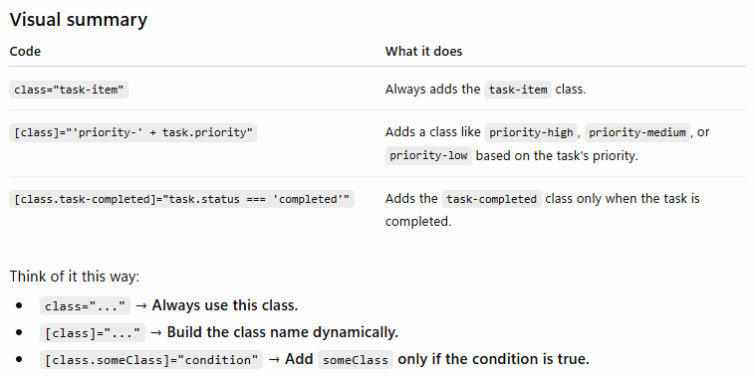
It will be used below css style:

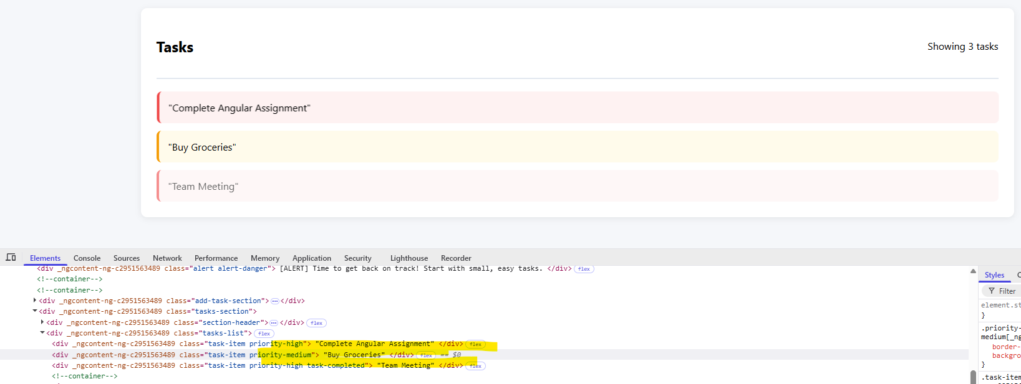

Create list information

- Check box
<input type="checkbox" class="task-checkbox" [checked]="task.status === 'completed'"
(change)="toggleTaskComplete(task.id)"/>

- TS:
- // change status from completed to pending so on
- toggleTaskComplete(id: number): void{

- // find the task by id
- const task = this.tasks.find(t => t.id === id);
- if(task){
- if(task.status === 'completed')
- {
- task.status = 'pending';
- delete task.completedAt;
- }
- else
- {
- task.status = 'completed';
- task.completedAt = new Date();
- }
- }
- }

- បើវា នៅក្នុង Condition in the status complete អោយវាលុយ ទិន្ន័យនឹងចោលហើយ change status to pending

- After we click on the check box it will change to pending

- Show the description and working, complete and due date
- <div class="task-content">
- <div class="task-header">
- <span class="task-number">{{idx + 1}}</span>
- <span class="task-title">{{task.title}}</span>
- </div>
- @if(task.description)
- {
- <p class="task-description">{{task.description}}</p>
- }
- <div class="task-meta">
- <span [class]="'category-tag category-' + task.category">{{task.category}}</span>
- <span [class]="'status-badge status-' + task.status">{{task.status}}</span>
- <span [style.color]="isOverdue(task)? '#ef4444' : '#64748b'">Due: {{task.dueDate.toLocaleDateString()}}</span>
- </div>
- </div>

- យើងពិនិត្យមើលលើលខ description បើវាមិនមានទេ យើងមិនចាំបាច់បង្ហាញនោះទេ
- @if(task.description)
- {
- <p class="task-description">{{task.description}}</p>
- }

- Condition on the date line: overdue
- isOverdue(task: Task): boolean
- {
- const today = new Date();
- today.setHours(0, 0, 0, 0);
- return new Date(task.dueDate) < today && task.status != 'completed';
- }

- បើសិនជាថ្ងៃដែលយើងកំណត់ វាផុតកំណត់ តូចជាង ថ្ងៃ នឹង ហើយ status មិនទាន់បានបញ្ចប់ យើងធ្វើការ
- វានឹងធ្វើការ return : true or false (សម្រាប់ធ្វើការកំណត់ style លើលក្ខណ)
- <span [style.color]="isOverdue(task)? '#ef4444' : '#64748b'">Due: {{task.dueDate.toLocaleDateString()}}</span>
យើងបន្ទាប់មកយើងបំលែងវា ទៅជា String.
- Create Button Click Delete
- <div class="task-actions">
- <button class="btn btn-danger" (click)="deleteTask(task.id)">Delete</button>
- </div>
TS:
deleteTask(id: number): void
{
const index = this.tasks.findIndex(task => task.id === id);
if (index !== -1)
{
this.tasks.splice(index, 1);
}
}
- យើងធ្វើការ ស្វែងរក តាមរយៈពេលយើងចុតលើ Button deleted នឹងសិន (click)="deleteTask(task.id) យើងចាប់យក Id ដែលពេលយើងធ្វើការ use event click នឹងសិន
- បើសិនជា id នឹងវាខុសពី -1 មានន័យថា វាមានតម្លៃ លេខនឹង ចឹងយើងធ្វើការ splice វាចេញ
យើងធ្វើការ ពិនិត្យនឹង @if (getFilteredTasks().length > 0) មានតម្លៃ តែបើសិនវាមិនមានតម្លៃវិញក្នុងលក្ខណ filter
យើងធ្វើការ Filter ទៅលើ ពេលដែលយើង Filter
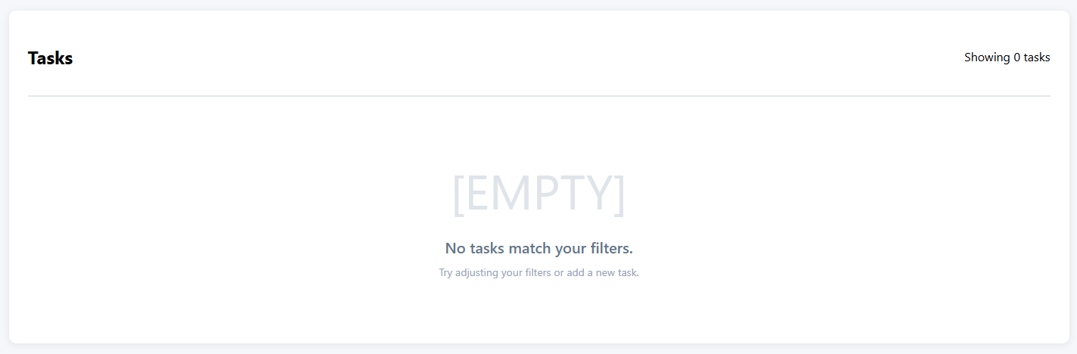

HTML:
@else {
<div class="empty-state">
<div class="empty-state-icon">[EMPTY]</div>
<div class="empty-state-title">
@if(filterStatus !== 'all' || filterCategory !== 'all' || filterPriority !== 'all')
{
No tasks match your filters.
}
@else {
No tasks yet.
}
</div>

<div class="empty-state-description">
@if(filterStatus !== 'all' || filterCategory !== 'all' || filterPriority !== 'all')
{
Try adjusting your filters or add a new task.
}
@else {
Add your first task to get started
}
</div>
</div>
}
- បើសិនជា filterStatus មិនស្មើរ ‘all’ … យើងប្រើ else ដើម្បីគ្រាន់តែធ្វើការ កំណត់ style of the text តែប៉ុន្នោះ
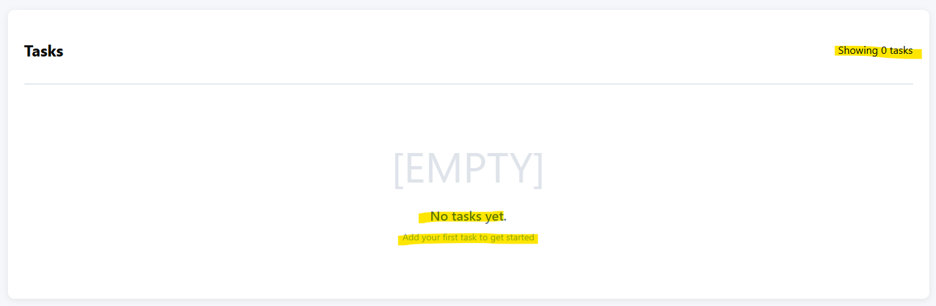

បើសិនមិនមាន add task ទេ អោយវាចេញ Add your first task to get started


<!-- Productivity Scroe starts -->
<div class="productivity-score">
<div class="score-label">Your Productivity Score</div>
<div class="score-value">{{getCompletionRate()}}%</div>
<div class="score-label">Keep going!</div>
</div>
<!-- Productivity Scroe ends -->

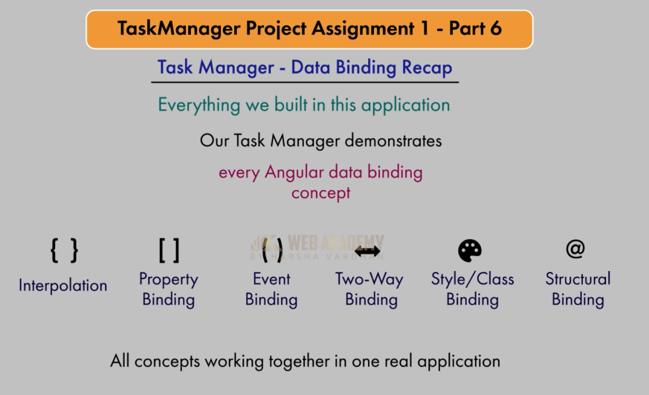

Link to get Hub:

